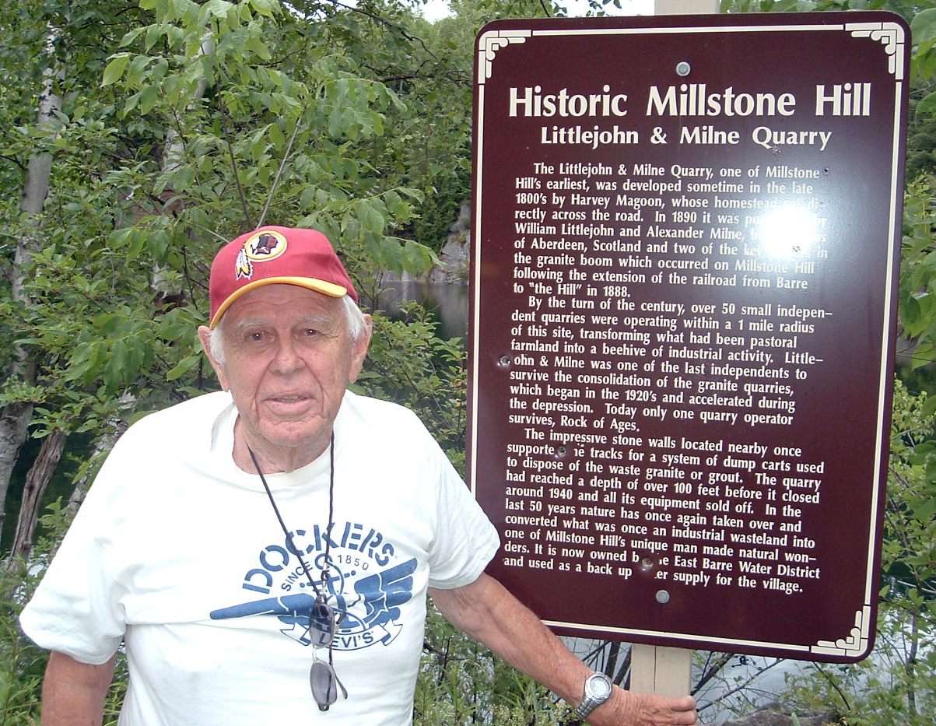
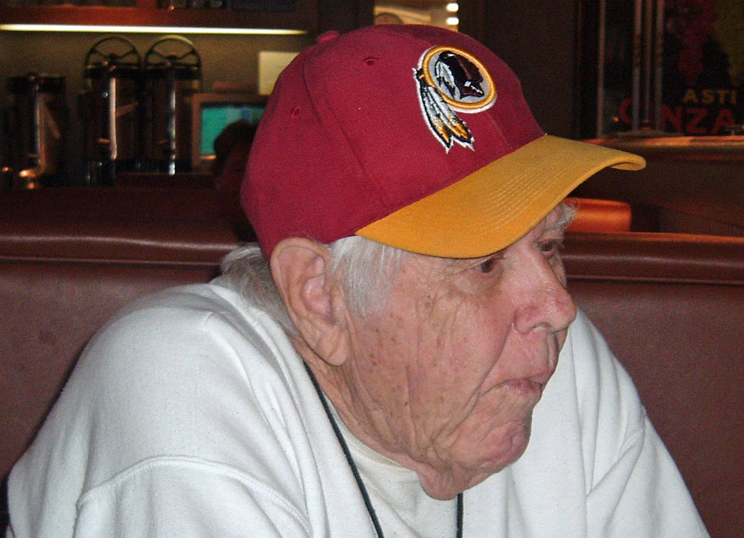

Thank you for attending this memorial gathering. Memorial contributions may be made to St. Jude Children's Research Hospital, 501 St. Jude Place, Memphis, TN 38105
William Littlejohn

Simpson
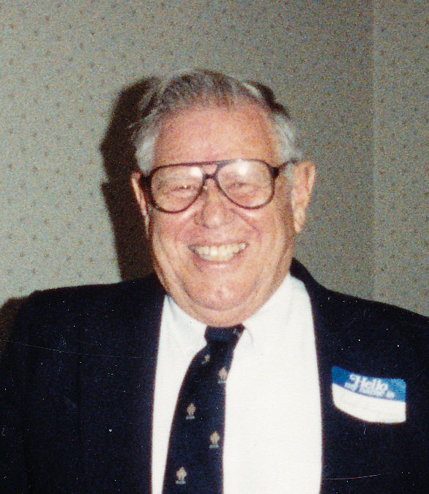
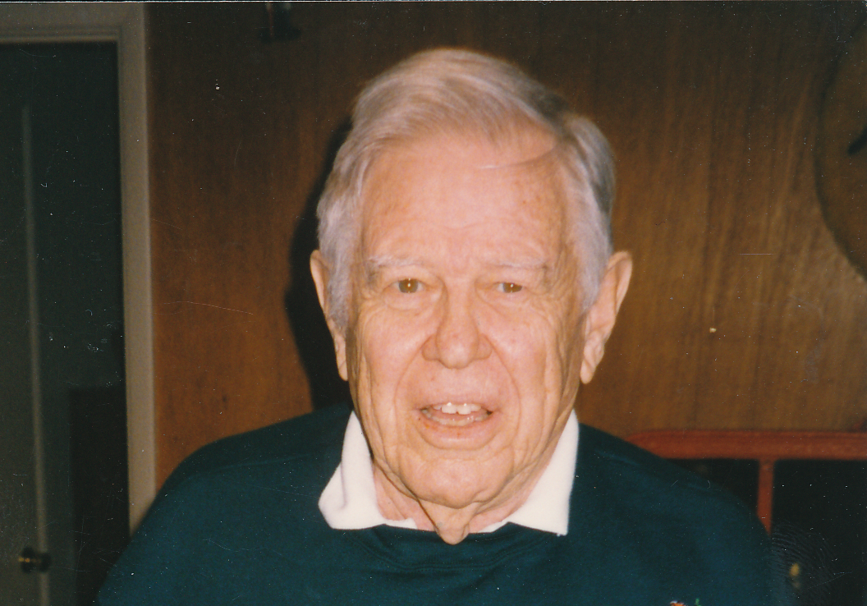

February 2, 1918

May 2, 2009

May the road rise up to meet you.
May the wind be always at your back,
May the sun shine warm upon your face,
And the rains fall soft upon your fields,
And, until we meet again
May God hold you in the palm of His hand.

--Anonymous

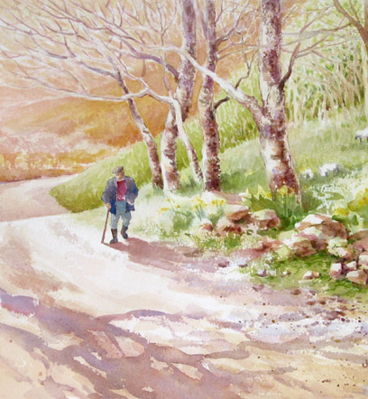
William L. Simpson

William L. Simpson was born in Barre, Vermont February 2, 1918, the son of Catherine L. and Alfred C. Simpson, and passed on May 2, 2009 of complications after breaking his hip.

He graduated from Spaulding High School in Barre and worked briefly in the granite industry before moving to Washington, DC & taking a job with the federal government.

He married his wife Helen in 1942. He entered the Army in 1943 and became a radio operator for the 45th Division during World War II (eight major campaigns, four amphibious landings, including the six month battle at Anzio, Italy).

After the war, he received his degree from GW University and had long career with the Veterans Administration as a budget analyst. After retirement, he led an active life and built a log cabin in Woodbury, Vermont. He also enjoyed hiking and swimming.

Survivors include his wife Helen M. Simpson; sons Robert L. Simpson, Craig G. Simpson; daughter Sheila D. Chapelle; grandchildren Heather Burgos, Laurel, Seth, Sean, Zoe, Mariah, Rowan & Ocoee Chapelle, Joseph A., Dana & Colin Simpson; great grandchildren Johnny Burgos & Andrew Simpson; sisters Margaret Hoare & Virginia Milne. He is also survived by many nieces, nephews and cousins.

